Use all diagnostic analysis tests (e.g. Pearson, Chi-Square etc.) on SPSS Statistics and find relationships between variables.

|  |  |  |  |
| --- | --- | --- | --- |
| **Correlations** | | | |
|  | | age | credit_amount |
| age | Pearson Correlation | 1 | .033 |
| Sig. (2-tailed) |  | .301 |
| N | 1000 | 1000 |
| credit_amount | Pearson Correlation | .033 | 1 |
| Sig. (2-tailed) | .301 |  |
| N | 1000 | 1000 |

Sig. is greater than 0.05. There is no significant correlation between age and credit amount.

|  |  |  |  |  |
| --- | --- | --- | --- | --- |
| **Correlations** | | | | |
|  | | | credit_amount | duration |
| Spearman's rho | credit_amount | Correlation Coefficient | 1.000 | .625** |
| Sig. (2-tailed) | . | .000 |
| N | 1000 | 1000 |
| duration | Correlation Coefficient | .625** | 1.000 |
| Sig. (2-tailed) | .000 | . |
| N | 1000 | 1000 |
| **. Correlation is significant at the 0.01 level (2-tailed). | | | | |

Sig. is less than 0.05 and Correlation coefficient (0.625) is between 0.30 and 0.70. There is significant medium correlation between variables.

|  |  |  |  |  |
| --- | --- | --- | --- | --- |
| **One-Sample Statistics** | | | | |
|  | N | Mean | Std. Deviation | Std. Error Mean |
| credit_amount | 1000 | 3271.26 | 2822.737 | 89.263 |

|  |  |  |  |  |  |  |
| --- | --- | --- | --- | --- | --- | --- |
| **One-Sample Test** | | | | | | |
|  | Test Value = 5000 | | | | | |
| t | df | Sig. (2-tailed) | Mean Difference | 95% Confidence Interval of the Difference | |
| Lower | Upper |
| credit_amount | -19.367 | 999 | .000 | -1728.742 | -1903.91 | -1553.58 |

P<0.05. It means there is significant difference between the mean of credit amount and 5000. The mean credit amount is less than population mean. Because mean difference is negative.

|  |  |  |  |  |  |
| --- | --- | --- | --- | --- | --- |
| **Group Statistics** | | | | | |
|  | foreign_worker | N | Mean | Std. Deviation | Std. Error Mean |
| credit_amount | yes | 963 | 3298.94 | 2806.007 | 90.422 |
| no | 37 | 2550.86 | 3186.172 | 523.803 |

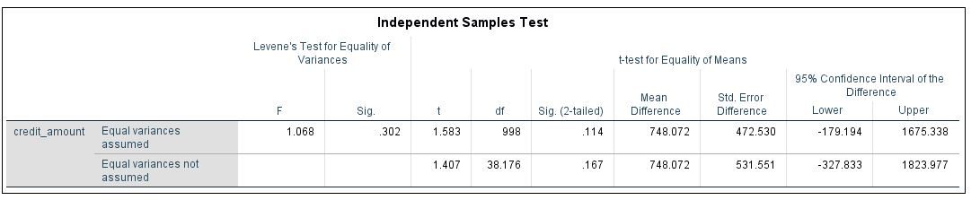

p>0.05. It means there is not significant difference between credit amount of foreign workers and non-foreign workers. Average credit amount of foreign workers is 748 more than non-foreign workers. But this difference is not significant for population.

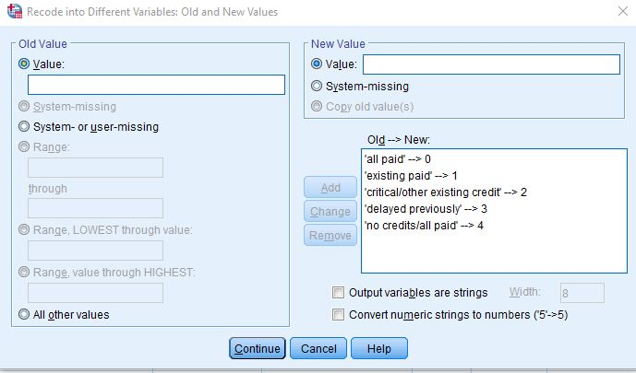

|  |  |  |  |  |  |  |  |  |
| --- | --- | --- | --- | --- | --- | --- | --- | --- |
| **Descriptives** | | | | | | | | |
| credit_amount | | | | | | | | |
|  | N | Mean | Std. Deviation | Std. Error | 95% Confidence Interval for Mean | | Minimum | Maximum |
| Lower Bound | Upper Bound |
| .00 | 49 | 3344.88 | 3122.875 | 446.125 | 2447.88 | 4241.87 | 339 | 14782 |
| 1.00 | 530 | 3040.96 | 2670.566 | 116.002 | 2813.08 | 3268.84 | 276 | 15857 |
| 2.00 | 293 | 3088.04 | 2502.829 | 146.217 | 2800.27 | 3375.81 | 250 | 14179 |
| 3.00 | 88 | 4302.60 | 3183.529 | 339.365 | 3628.08 | 4977.13 | 585 | 15653 |
| 4.00 | 40 | 5305.68 | 4268.980 | 674.985 | 3940.39 | 6670.96 | 426 | 18424 |
| Total | 1000 | 3271.26 | 2822.737 | 89.263 | 3096.09 | 3446.42 | 250 | 18424 |

|  |  |  |  |  |  |
| --- | --- | --- | --- | --- | --- |
| **Test of Homogeneity of Variances** | | | | | |
|  | | Levene Statistic | df1 | df2 | Sig. |
| credit_amount | Based on Mean | 7.499 | 4 | 995 | .000 |
| Based on Median | 5.155 | 4 | 995 | .000 |
| Based on Median and with adjusted df | 5.155 | 4 | 935.058 | .000 |
| Based on trimmed mean | 6.919 | 4 | 995 | .000 |

|  |  |  |  |  |  |
| --- | --- | --- | --- | --- | --- |
| **ANOVA** | | | | | |
| credit_amount | | | | | |
|  | Sum of Squares | df | Mean Square | F | Sig. |
| Between Groups | 297368722.642 | 4 | 74342180.661 | 9.654 | .000 |
| Within Groups | 7662506904.794 | 995 | 7701011.965 |  |  |
| Total | 7959875627.436 | 999 |  |  |  |

|  |  |  |  |  |
| --- | --- | --- | --- | --- |
| **Robust Tests of Equality of Means** | | | | |
| credit_amount | | | | |
|  | Statistica | df1 | df2 | Sig. |
| Welch | 5.628 | 4 | 142.543 | .000 |
| a. Asymptotically F distributed. | | | | |

I transformed credit history variable into new variable. P=0. It means there is a statistically significant difference between different level of credit history. Means of different level of credit history are different.